

**Cosmi Code internship**

**Name**:Mustafa Ihsan **Module:** Cyber Security

**Week 4#**

**Harden a Linux system by disabling unnecessary services and ports:**

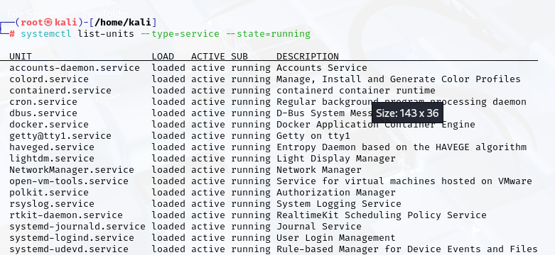

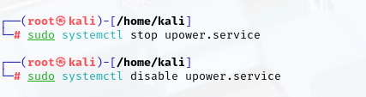

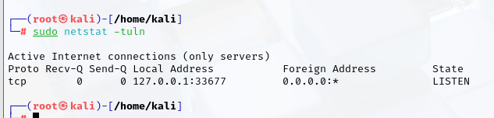

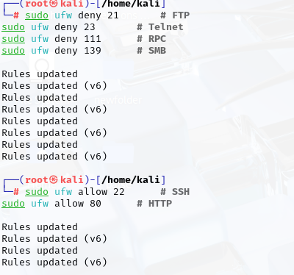

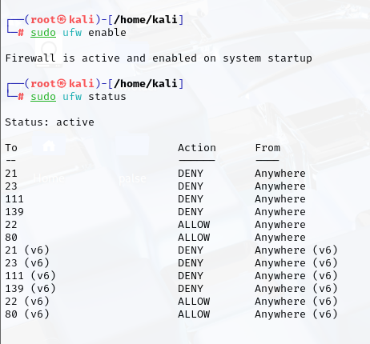

**Create and manage user accounts with specific permissions:**

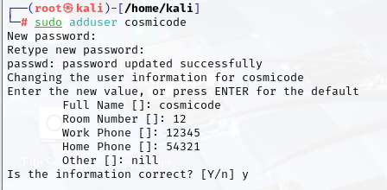

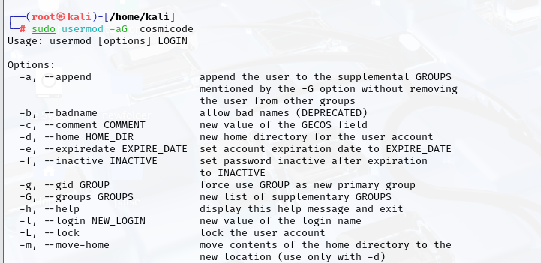

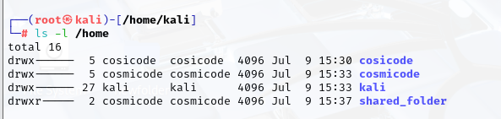

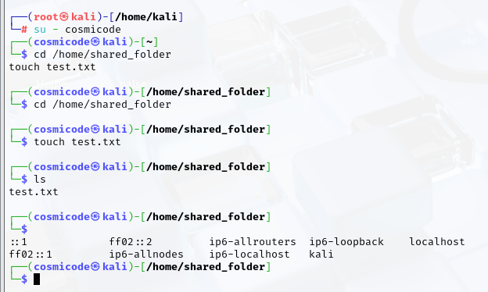

**Install and configure an Intrusion Detection System (IDS) like Snort or OSSEC:**

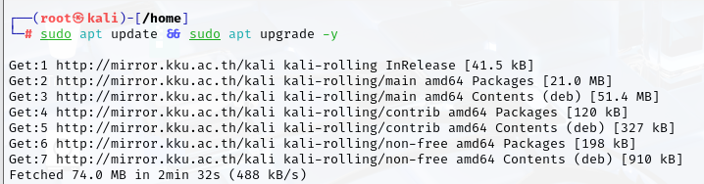

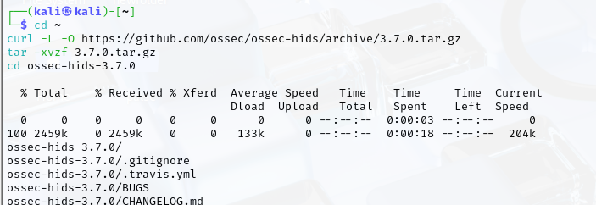

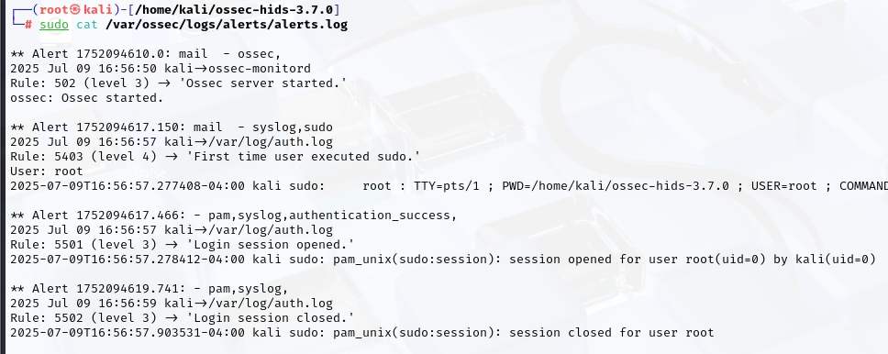

**Perform a system vulnerability scan using OpenVAS or Nessus:**

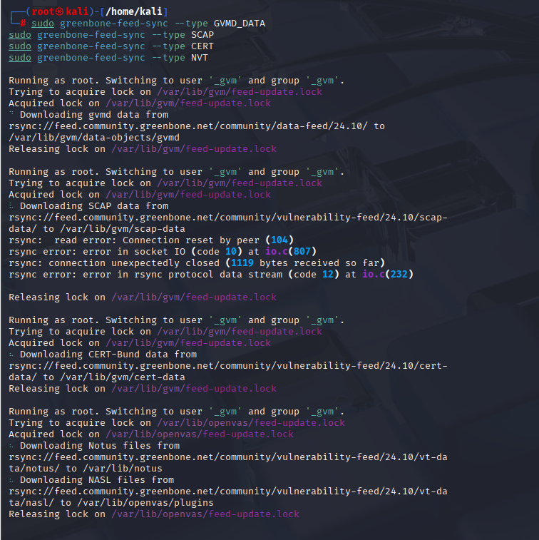

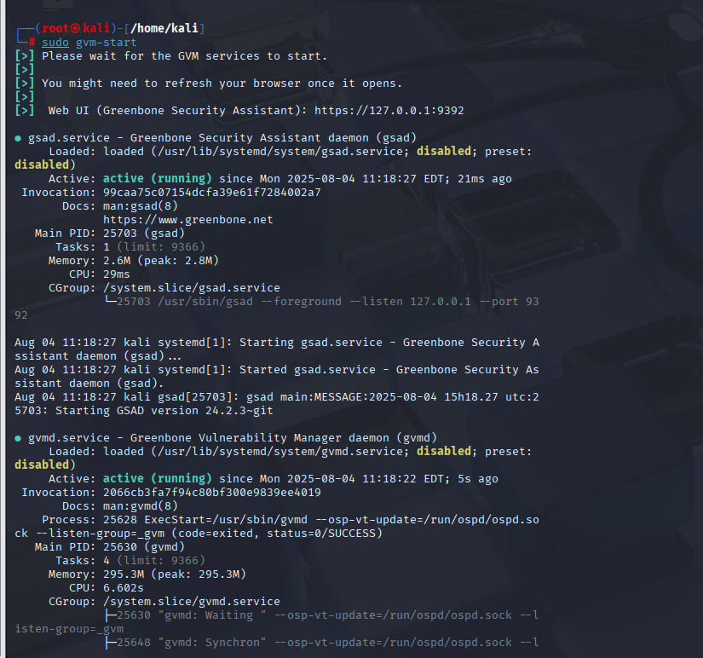

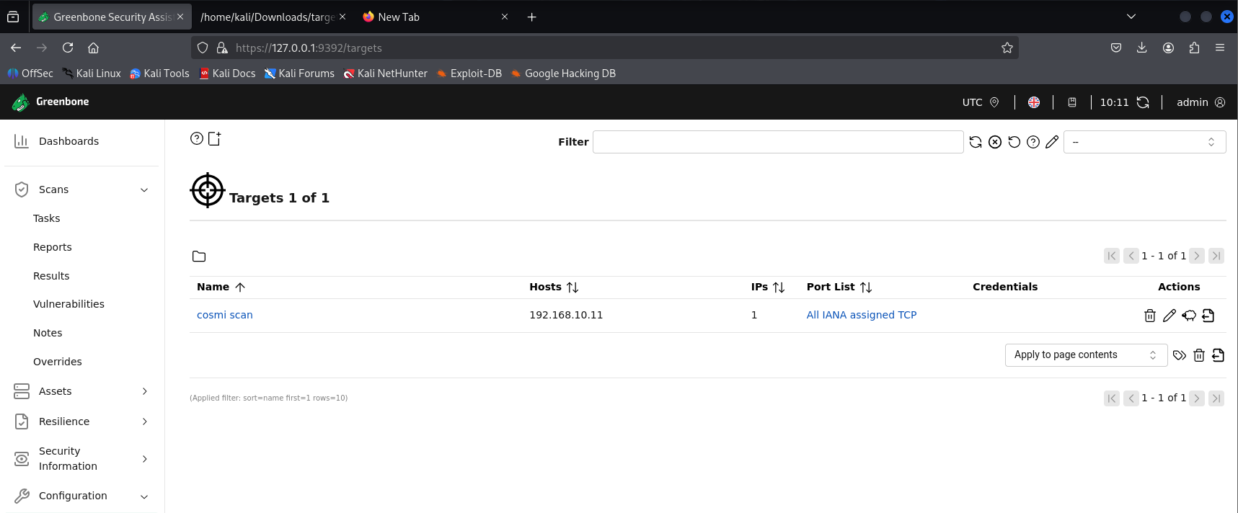

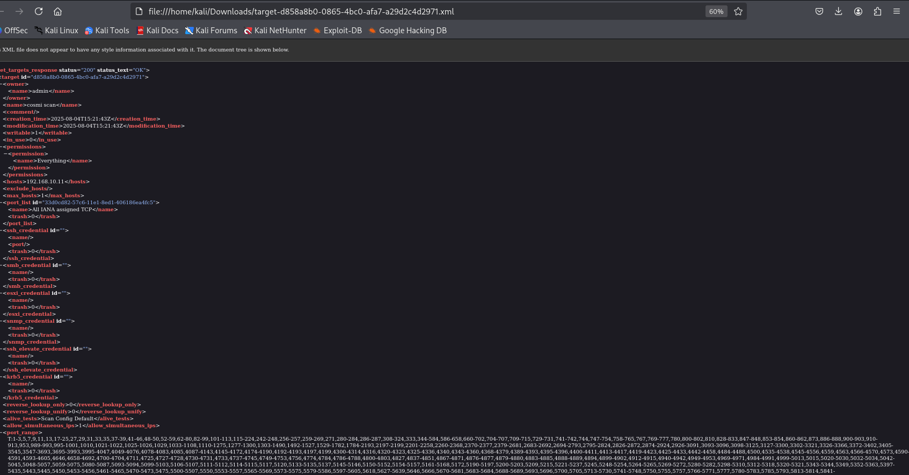

**Apply security patches and updates to a Linux system:**

